ValueObjectFactory

A J2EE system using value objects finds that its value object layer tends to change very often.
How should value object creation and consumption logic be implemented, in order to minimize the impact of frequent changes in the value object layer on the rest of the system?
* * *
Value Objects have a tendency to change often. Domain Value Objects change whenever the domain objects change (adding a new attribute to an entity bean, etc). Custom Value Objects are just use case specific data holders for transporting data across a network; they can change as frequently as your application’s presentation view. A medium to large application could potentially have tens to even hundreds of different Value Objects, each of which would require custom logic to create it. A critical question then becomes: how and where should this logic be implemented, in order to decouple and protect the rest of this system from value object changes?
A common solution employed in EJB 1.X applications is to place getXXXValueObject/setXXXValueObject methods directly on entity beans. In this scenario, the entity bean would be responsible for populating this value object, and updating itself based on the attributes of the set value object. The problem with this approach is that it tightly couples the value object layer to the entity bean layer. That is, placing use case specific value object creation code on an entity bean could cause serious dependencies between your entity beans and your clients in medium to large sized applications. Every time a web page changed and a different view of the data model was required, you would have to add a new method to an entity bean, recompile your entity bean, and redistribute your remote interfaces to any client using them.
Entity beans are supposed to be reusable business components, which can be separately assembled to create an application. In order to build truly reusable business components, it is important to maintain strict separation between your application logic and your business logic, allowing the two to evolve separately. Some other solution is required for creating and consuming entity beans, one that can decouple value object related logic from other components in the system.
Therefore,
Place the responsibility for creating and consuming Value Objects in a ValueObjectFactory.
A Value Object Factory separates the logic related to Value Objects (part of the application domain) from other components in your system such as entity beans (part of the business domain). When new views or different subsets of server side data become necessary, new value object creation methods can be added to the ValueObjectFactory. These new methods will interact with the entity bean layer (or any other source of data such as JCA connectors, straight JDBC, etc), calling getters and traversing relationships as required to generate domain or custom value objects. The advantage to this approach is that the entity beans themselves do not need to know about these different views of their data, in-fact, no code on an entity bean needs to be changed at all.
A ValueObjectFactory (using our Car example) would like:
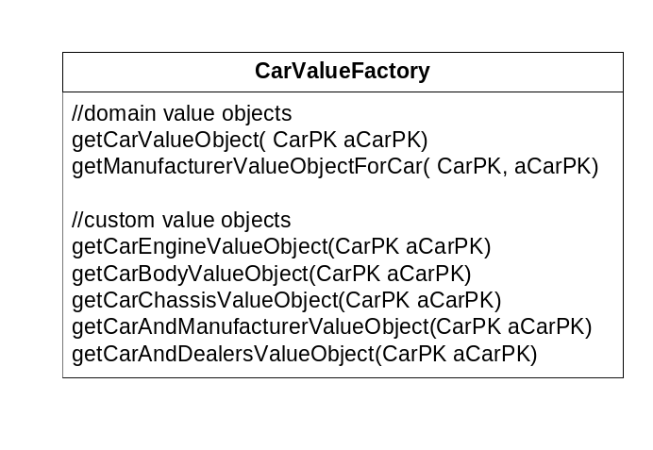
Figure x.x: CarValueFactory

There are two fundamental ways to implement the ValueObjectFactory pattern, depending on whether the client of the factory is a session bean or a non-ejb client such as a servlet. When used behind a session bean façade, the value object factory can be implemented as a plain java class that simply stores creation/consumption logic for different value objects in its methods. This type of Factory lends itself well to reuse as the value objects it generates can be reused across different session beans and/or in different projects.
When used from a non-ejb client, the ValueObjectFactory should be implemented as a stateless session bean. A typical interaction between this client and the value object is outlined in figure x.2. Here, a servlet client wants to get a CarAndManufacturerValueObject , so it queries a CarValueFactory for this object. The CarValueFactory then creates and populates this view value object by calling get methods on the Car and its related Manufacturer entity bean through their local interfaces.
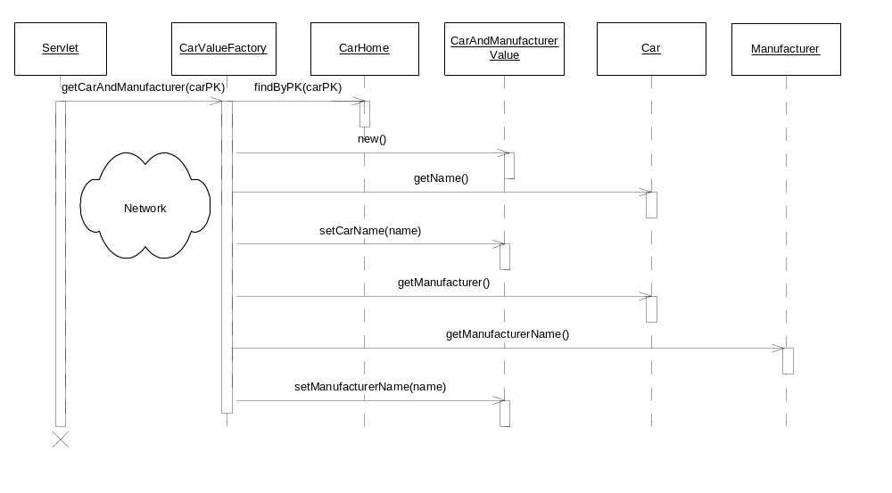
Figure X.2: Car Value Factory as Session Bean Interactions

Value Object Factories can be used to easily create any type of value objects. Even complex hierarchies of Aggregate Value Objects (domain value objects that contain other domain value objects) can be created that map to different slices of the server side entity bean object model. Complex value object hierarchies can be created by explicitly writing logic that knows how to navigate (and copy) a use-case specific slice of a hierarchy of entity beans. These value object hierarchies can all be created upfront on the server, and passed to the client in one network call.
One important benefit that results from this practice is that the entity beans in our application are now fully reusable. For example, imagine two separate development teams in a corporation working on separate applications. These two teams can reuse the same entity bean business components (a beautiful example of EJB reuse in action by the way) by using separate Value Object Factories. The teams could achieve complete reuse by each maintaining its own separate value object factory that passed out use-case specific value object ‘slices’ of entity bean state independently of the other team. By maintaining their own Value Object Factory, they could also develop and deploy their own applications completely independently from each other. This concept is illustrated in figure X.3.

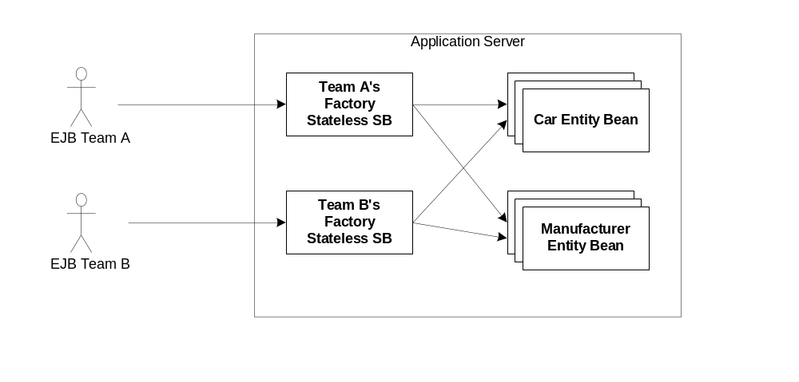
Figure X.3: Achieving Entity Bean Reuse with Value Object Factories

Note that the Value Object factory pattern does not imply creating one Value Object Factory for each entity bean class. For example you don’t necessarily need to create a CarValueFactory for a Car entity bean. Where requirements are simple, it can be more straightforward to create a Value Object Factory for a whole set of entity beans. When implemented as a stateless session bean, this factory becomes equivalent to the Session Façade pattern.
Value Object Factories provide a way to read data from the server, but what of updating? The most common way to update data is by passing a Domain Value Object (see the Domain Value Object pattern) to an updateXXXEntityBean method on a ValueObjectFactory, which would copy the attributes of the value object into the appropriate server side domain object (such as an entity bean) using fine-grained set methods through the entity beans local interface.
A common difficulty faced by developers is how to choose at what granularity to update server side data. Should updates be performed at the domain object level (ie: update a Car using a CarValueObject in one transaction) or should arbitrary sets of server side data be updated in one transaction (such as updating a Car and Manufacturer together using the CarAndManufacturer Custom Value Object)? Ideally these decisions should be requirements driven. However, updates at the domain object level are typically the norm. Domain objects such as entity beans already define a well-understood unit of data in a system. This unit of data is thus an excellent starting point for performing updates.
Using the previous example, if the application administrator wanted to update a Car or a Manufacturer, these updates would be done with separate UI displays (one for the Car, and one for the Manufacturer). Updates would be performed and either a Car or a Manufacturer Domain Value Object would be sent back to the server for updating in a single transaction, as in figure X.4.

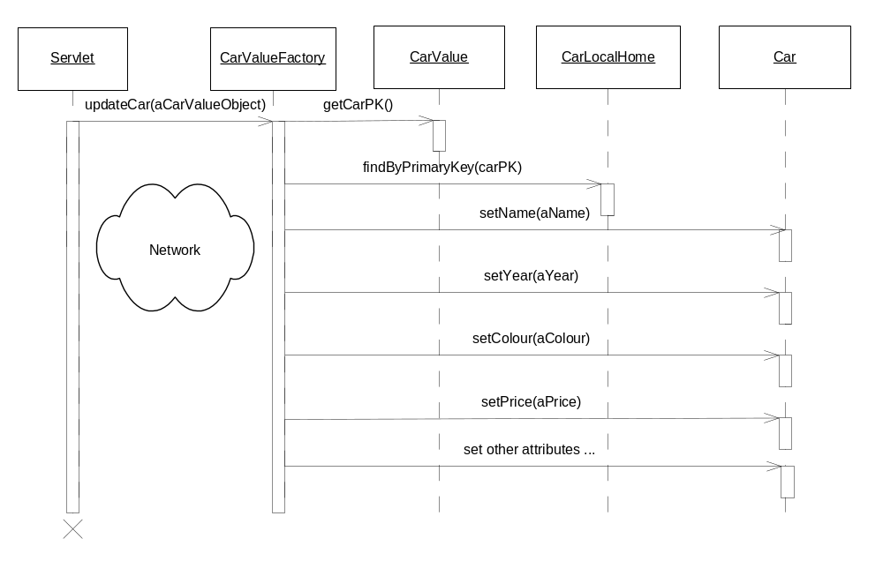
Figure X.4: Updating using a Value Object Factory

The advantages to the Value Object Factory approach are numerous:
Better maintainability. By separating between your application logic (use-cases) and your data object model (entity beans), the two can evolve separately. Entity beans no longer need to be changed and recompiled when the needs of the client change.
Encourages entity bean reuse. Entity beans can be reused across projects, since different Value Object Factories can be written to suit the needs of different applications.
Allow for creating complex value object graphs. By writing value object creation logic upfront, developers can create complex graphs that mimic one-to-one, one-to-many, many-to-many, cyclic, and combinations of such relationships, providing clients with fine grained control over what parts of entity bean data they need to display. For non-web clients such as java apps and applets, the ability to get non-tabular data is particularly important.
Increases performance. When the Value Object Factory is uses as a Session Façade, attributes from multiple entity beans can be passed to the client with just one network call.
The Value Object Factory pattern can build maintainable and flexible systems, providing a simple and consistent method for creating arbitrarily complex value objects and passing them to the client in one bulk network call, without causing dependencies between value objects and other components in a J2EE system.

